**Domaći BUG REPORT**

**Summary**: Cart icon overlaps dropright button of first item listed on first dropdown menu sublevel

**Description:**

When user use Mozilla Firefox browser on android mobile device for URL: “https: //vetapotekanikolic.rs/”, clicks on the hamburger dropdown menu button on the main page, dropdown first sublevel content is displayed below the dropdown button. The first item listed in that sublevel with the name “Psi” on the right side has dropright button which is overlapped with the cart icon. When user clicks on overlapped dropright button, a textbox with the message “Nema proizvoda u korpi” is displayed below the cart icon.

**Steps**

1. Open Mozilla Firefox browser on android mobile device

2. Go to following URL: <https://vetapotekanikolic.rs/>

3. Click on the hamburger dropdown menu button in the center of the upper part of the screen

*notice the first item listed in opened sublevel with the name “Psi” on the right side has dropright button which is overlapped with the cart icon

4. Click on overlapped dropright button of item named “Psi”

**Expected result**

The second dropdown sublevel opens below the list item named “Psi”.

*expected result example displayed using Chrome browser on same android device (screenshot)

**Actual result**

A textbox with message “Nema proizvoda u korpi” is displayed below the cart icon.

**Priority:** Medium

**Severity:** Medium

**Repro rate:** 100%

**Screenshot**

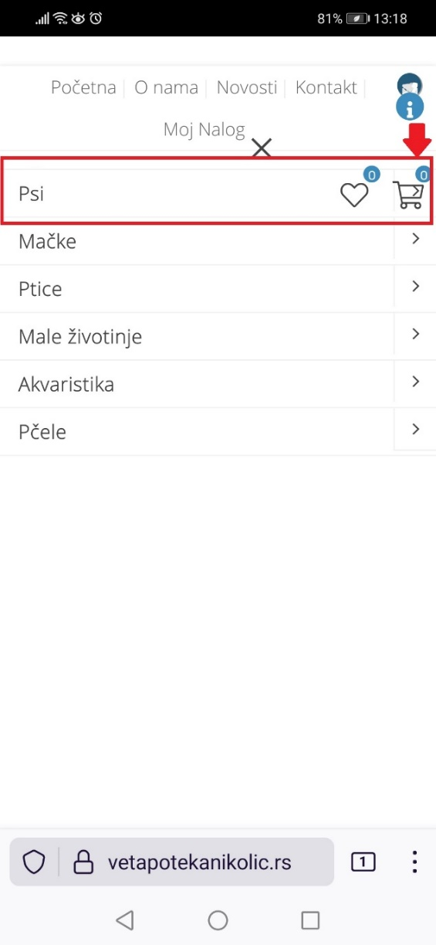 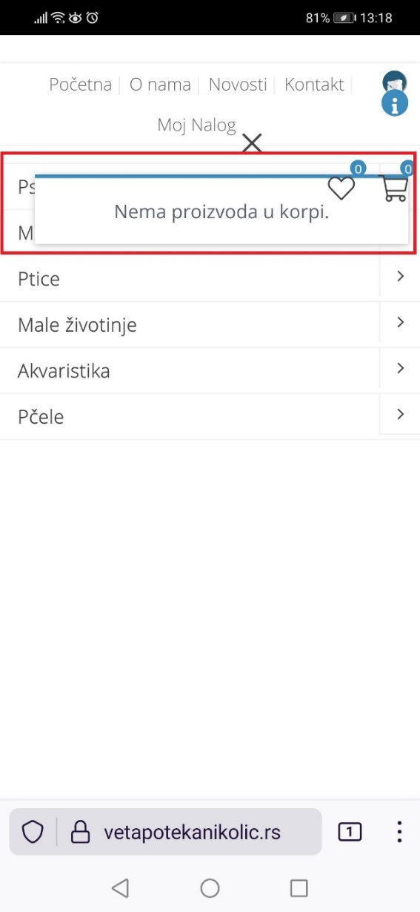 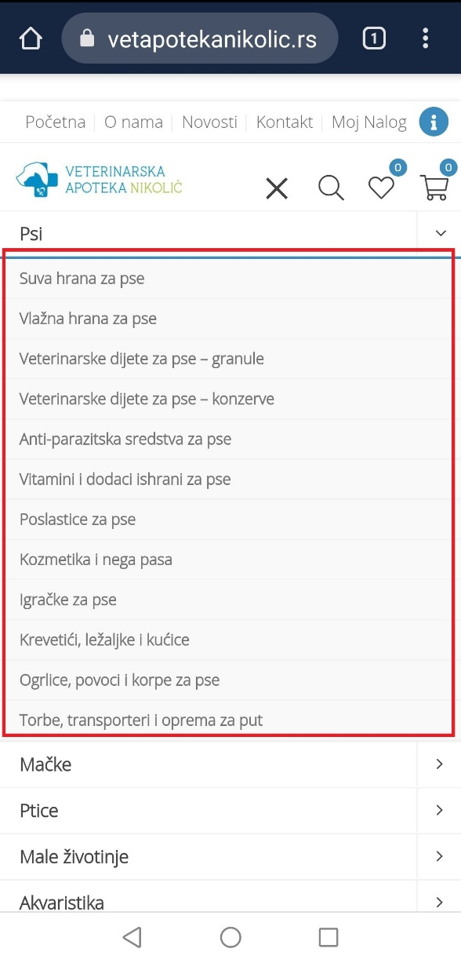

**Comments:**

Overlapping don’t appear in Desktop site view on Mozilla Firefox browser on android mobile device

**Labels:** Mozilla Firefox, Dropdown menu, Overlapping